**Problem Statement:**

Consider yourself to be Sam who is a student at a prestigious university. You have enrolled for the SQL course and it is your first semester.

**Tasks To Be Performed:**

1. Install MS SQL Server.

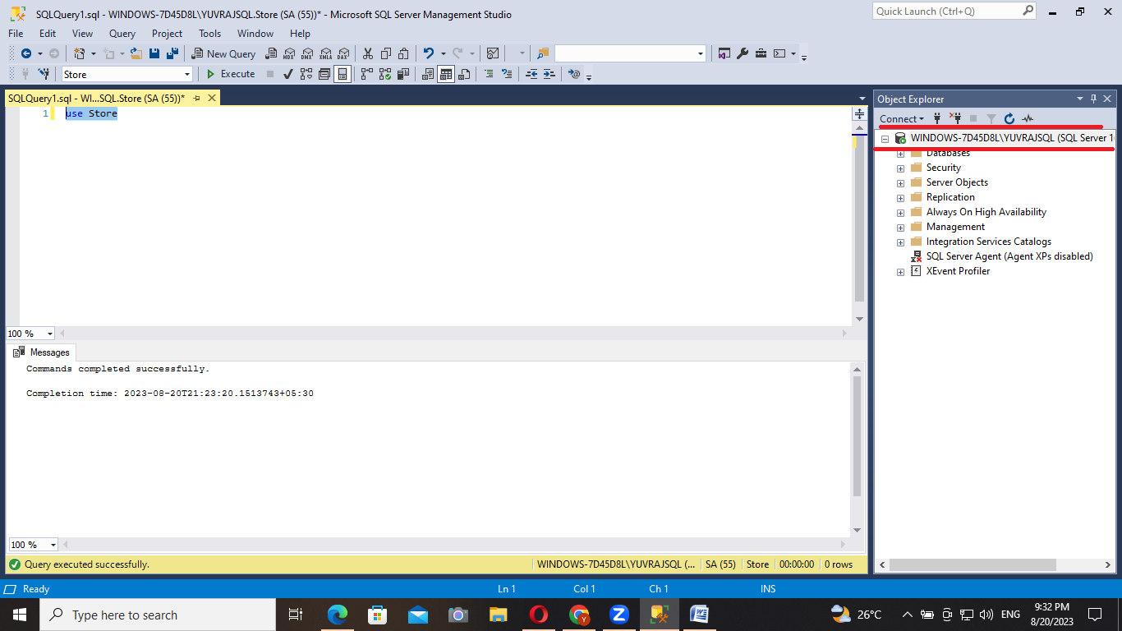

Steps:

* Open the Microsoft official website for SQL downloads.
* Select developer mode and install it.
* So in installation type choose custom and install it.
* In sql installation center go on installation & choose new sql servor standalone installion.
* In sql servor setup choose free edition for developer .
* Accept the license terms.
* Use Microsoft update to check in install rules page we need to make sure that all the fetures are passed except windows firewall as warning..
* On azure extension page uncheck the “Azure extension for SQL servor”.
* In feature selection select database engine services and sql server replication.
* In instance configuration choose named instance and give a instance name.
* In server configuration make the SQL browser disabled to automatic.
* Finally in database engine configuration choose mixed mode and give the password confirm the password and select add current user.
* On ready to install click on install.
* Install ssms from management tools.
* Once installation is completed open ssms and the make connection.

1. Give the difference between Char and Varchar data type.

* Char is fixed length of datatype it will allocate the entire space even though when its not required or not in usage ,it’s a static memory alloction, Slightly faster than Varchar .
* Varchar is variable length of datatype it will allocate only the required memory, it is dynamic memory alloction , Slightly slower than char.

1. Explain the types of SQL Commands.

**DDL: Data Defination Language**

DDL is used to create new database tables ,defining the columns, datatypes,constraints, and other attributes of the table.

Commands: Create,Alter ,Drop(CAD Commands)

**Create** command is used to create a structure like database or a table.

Example: create database august20

Create table employee(employee_id int ,employee_name varchar(30),salary int)

**Alter:** it is used to make any changes or alter a record in a table.

Alter table employee add designation varchar (30)

**Drop:** drop is used to drop the database or a table completely.

Drop database database_name

Drop table table_name

**DML: Data Manipulation Language**

Dml is used to manipulate the data present in the databse.

Commands: Insert, Update, Delete

**Insert:** This command allows the users to insert thre rows amd columns into the table.

Insert into table_name values(value1, value2,……….,.)

**Update:** When any modification is required is required we can use update .

UPDATE table_name SET column1=new_value1,column2=new_value2

WHERE condition;

**Delete:** delete from table _name where condition

**DQL: Data Query Language**

**Select:** retrieving the data

**DCL: Data Contro Language**

Commands:Grant revoke

1. Explain NVarchar and Nchar.

**Nvarchar** is used to store variable length Unicode character data.

(n’ Chinese language)

(n’ (*#%%))

**Nchar**  is used to fixed length Unicode character data.